“Amaxophobia* Fear of driving or riding in vehicles - the inability of riding or entering an automobile, either as a driver or a passenger. This means avoiding vehicles at any cost.”
-- http://www.designedthinking.com/Fear/Phobias/defined/defined.html
Game Theory--There Needs to be a backstory, get a bunch of people who have Amaxophobia, put them in cars, take off the brakes and hardwire the pedal to full gasoline = a really moral and humane act
Car game
Game play-
- Ammo is replenished upon completing a lap
- Hardcore vs. core physics
- Clan tag on license plate
- Interactive environment/bots
- Co-op game mode: driver + passenger (caters to social gaming crowds).
- Survival (zombies chase, elimation, no teams: kill anyone or work together)
- Arms race (start with no weapons, get a better weapon at each checkpoint)
- Maps have multiple routes, all of which are constantly changing
Each car has different stats-
- Acceleration
- Max speed(v)
- Traction
- No2
- Health
- Weight

Physics:
Turning R = v^2/g(Mu)
Turning (Bank) R = v^2/gx
Higher R → lower sensitivity at said speed.
V/(2(pi)R) = Degrees/360
V = velocity, g = constant, (Mu) = multiplier for traction, higher is better.
(Mu) is found by multiplying car traction (Mu) by ground (Mu) (mud is bad, etc).

No2 = Force(constant)/mass
Landmine Jumping—take heavy damage, get mad hops
Speed(max) = (Speed(x)^2 + Speed(y)^2)^(1/2)
Momentum(x) = Speed(x) * Weight
Momentum(y) = Speed(y) * Weight
During Collsion(1-2): [Momentum(x2) + Momentum(x2)] Weight(1+2) = Speed(x)
During Collsion(1-2): [Momentum(y2) + Momentum(y2)] Weight(1+2) = Speed(y)
PostCollisionSpeed = (Speed(x)^2 + Speed(y)^2)^(1/2)(Weight)
PostCollisionDamage = [Speed(initial) – speed(final)]*Constant
Walls: Treat Weight As infinitely High, thus speed will instantly go to zero.
Defensive weaponry- Controlled by driver
- Oil(makes the cars traction bad for a period of time)
- Caltrops(does damage to the car overtime)
- Smoke(blinds the car)
- Landmine(explodes on impact, can be upgraded to propel from bottom of car-cause massive damage)
- Gravity lift(propels the car into the air)
- Teleporter(sends car back certain amount of feet)
Offensive weaponry-Controlled by Passenger
- Browningx2(light, 300) 2 points
- Browningx2(moves left and right, light, 300) 2 points
- Vulcan(mounted, heavy, 500) 5 points
- Rocket launcher(mounted, heavy, 10) 5 points
- Mini rocket launcher(medium, 20) 4 points
- Grenade launcher(medium, 30) 3 points
- Chainsaw(underneath, medium, 1) 3 points
- SSM missiles(mounted on back, heavy, 4) 6 points
- Tow missile(mounted, heavy, 5) 6 points
- Burrow missile(shoots heat seeking missile from bottom of car, can only be used when car is lifted in the air, 1) 4 points
- MG 42x2(moves left and right, up and down, light, 300) 2 points

Armor types-
- Weak(move fastest)
- Medium(move slower, increase health/weight) (+50hp) (-5mph) (+1000lb)
- Heavy(move slowest, increase health/weight more) (+100hp) (-10mph) (+2000lb)
Cars-
- 2007 Dodge Charger SRT8 Super Bee
- Lamborghini Diablo
- 356A Porsche
- Ford F150
- Jaguar XJ 220
- Ferrari
- 2006 Acura RSX coupe
- Hum V
Car stats-
- 2007 Dodge Charger SRT8 Super Bee-
- Acceleration: 0-60 in 5.0sec, 0-100 in 11.6sec
- Max Speed(v): 165mph (200mph)
- Traction: stable, takes 324ft to slow down from 135mph
- No2: 200000/weight, 5sec use, 20sec recharge, cannot use until No2 is full.
- Health: muscle car(425hp)(500hp)
- Weight: 4168lb

- Lamborghini Diablo-
- Acceleration: 0-60 in 4.5sec, 0-100 in 9.3sec
- Max Speed(v): 202mph
- Traction: good grip, cornering ability, crappy agility
- No2: 200000/weight, 5sec use, 20sec recharge, cannot use until No2 is full.
- Health: super car(492hp)(490hp)
- Weight: 3564lb

- 356A Porsche-
- Acceleration: 0-60 in 13.50sec
- Max Speed(v): 110pmh (185mph)
- Traction: outstanding road handling
- No2: 200000/weight, 5sec use, 20sec recharge, cannot use until No2 is full.
- Health: sports car(95hp)(410hp)
- Weight: 2000lb

- Ford F150-
- Acceleration: 0-60 in 8.9sec
- Max Speed(v): 105mph (195mph)
- Traction: takes 150ft to slow from 60ft
- No2: 200000/weight, 5sec use, 20sec recharge, cannot use until No2 is full.
- Health: pickup(420hp)(550hp)
- Weight: 4980lb

- Jaguar XJ 220-
- Acceleration: 0-60 in 4.9sec
- Max Speed(v): 198mph
- Traction: agile handling
- No2: 200000/weight, 5sec use, 20sec recharge, cannot use until No2 is full.
- Health: super car(450hp)(450hp)
- Weight: 3885lb

- Ferrari-
- Acceleration: 0-60 in 3.7sec
- Max Speed(v): 205mph
- Traction: excellent grip
- No2: 200000/weight, 5sec use, 20sec recharge, cannot use until No2 is full.
- Health: exotic(620hp)(400hp)
- Weight: 3486lb

- 2006 Acura RSX Coupe-
- Acceleration: 0-60 in 7.1sec, 0-100 in 18sec
- Max Speed(v): 155mph (193mph)
- Traction: nimble handling, takes 170ft to slow from 60mph
- No2: 200000/weight, 5sec use, 20sec recharge, cannot use until No2 is full.
- Health: sports car(255hp)(430hp)
- Weight: 2840lb

- Hum V-
- Acceleration: 0-60 in 7.9sec
- Max Speed(v): 65mph (190mph)
- Traction: all terrain, great traction
- No2: 200000/weight, 5sec use, 20sec recharge, cannot use until No2 is full.
- Health: armored car(190hp) (600hp)
- Weight: 5200lb

ART:
2007 Dodge Charger SRT8 Super Bee
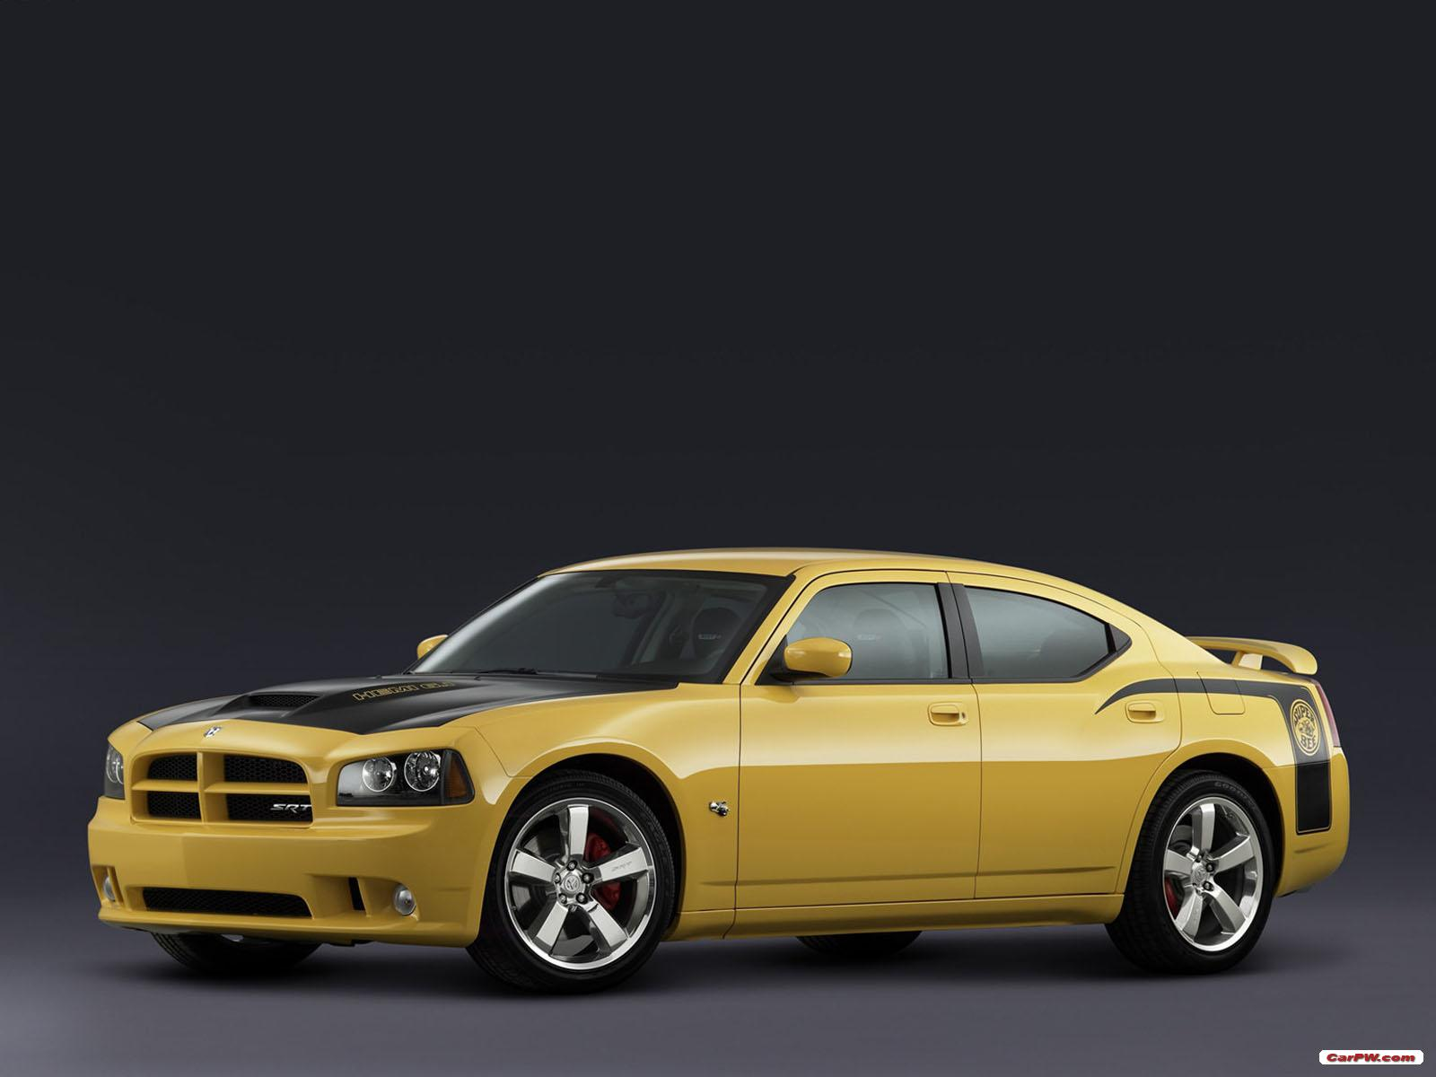

Lamborghini Diablo
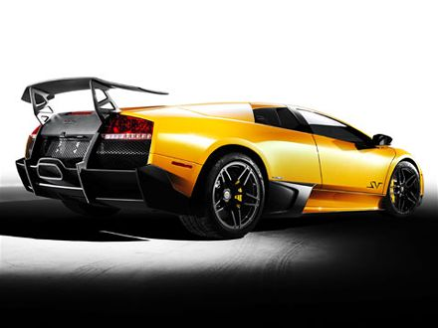
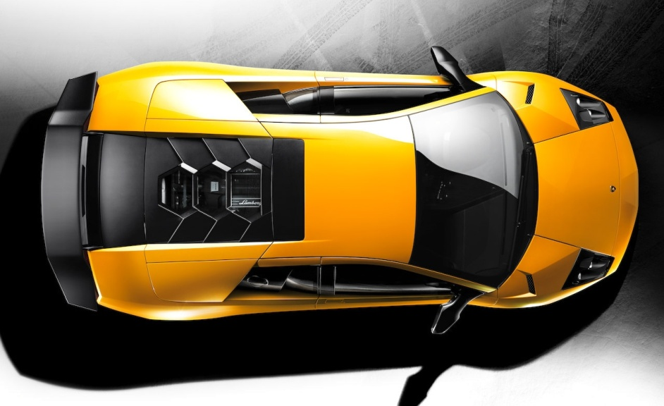

356A Porsche
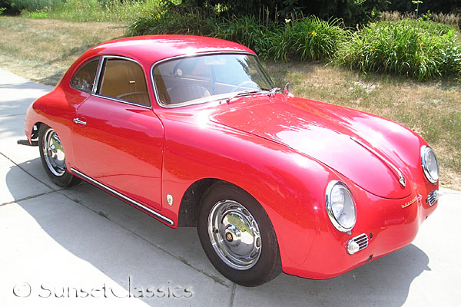

Ford F150
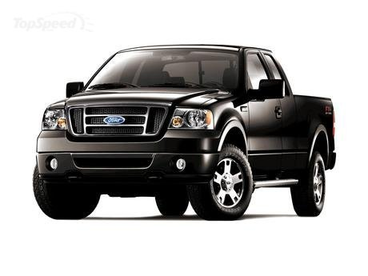
Jaguar XJ 220
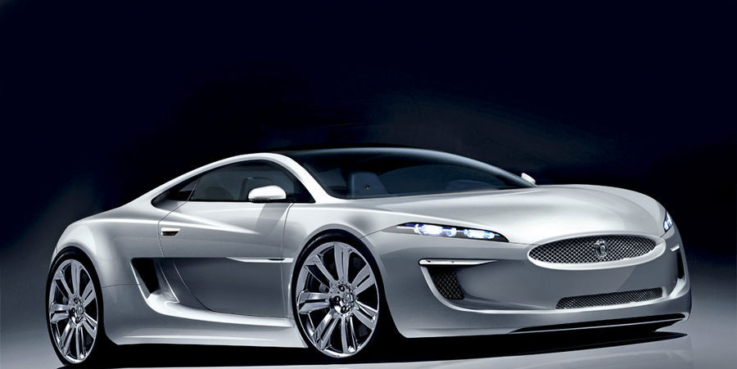
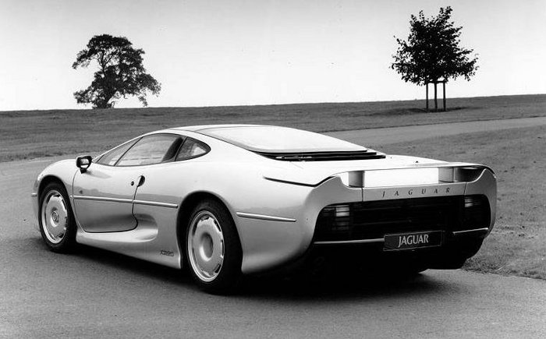

Ferrari
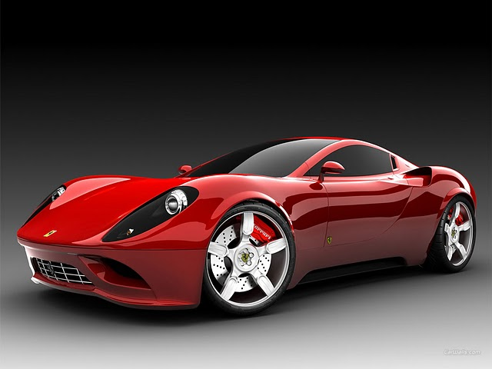
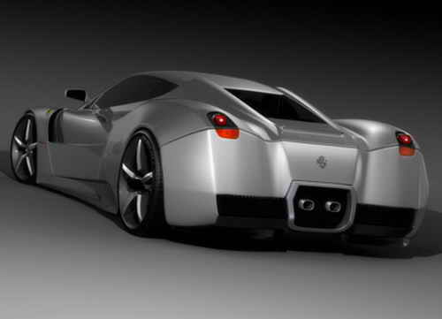

2006 Acura RSX Coupe
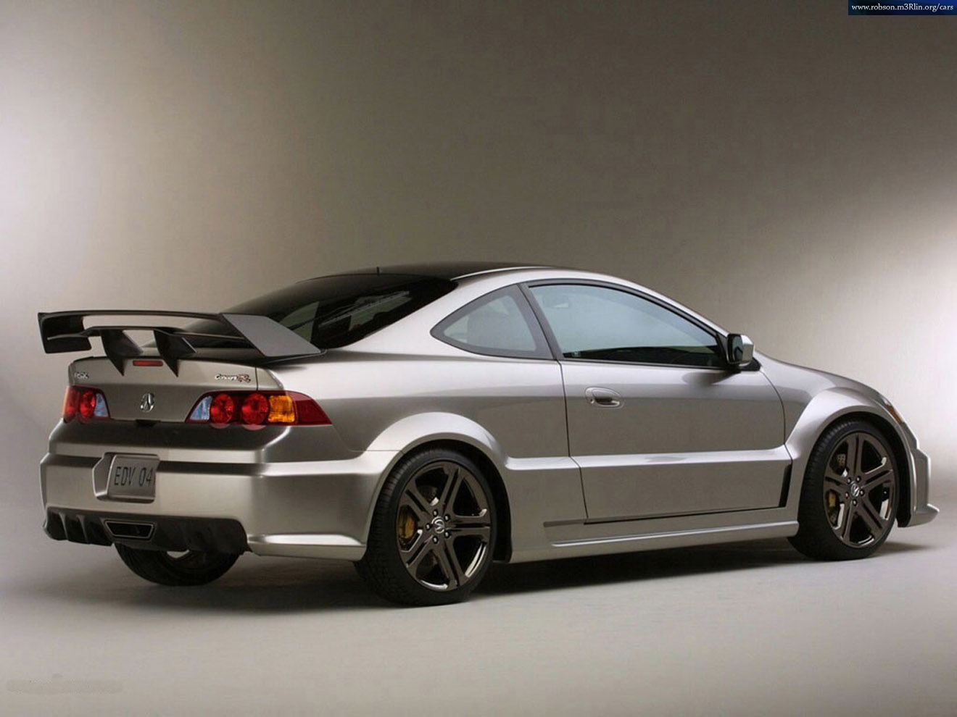
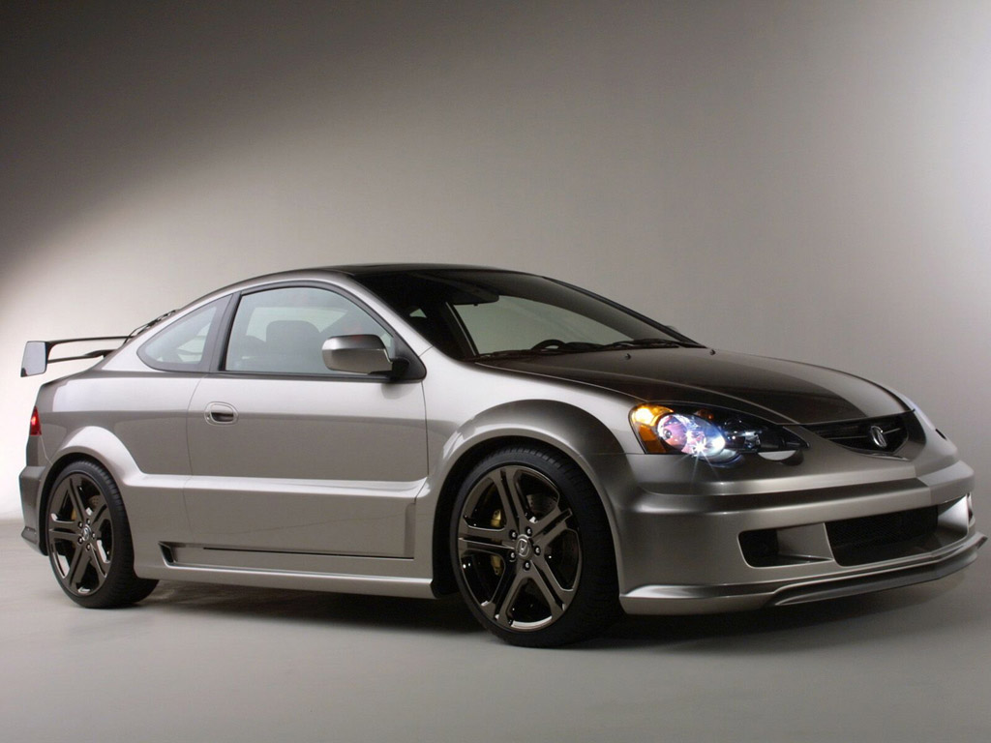

Hum V
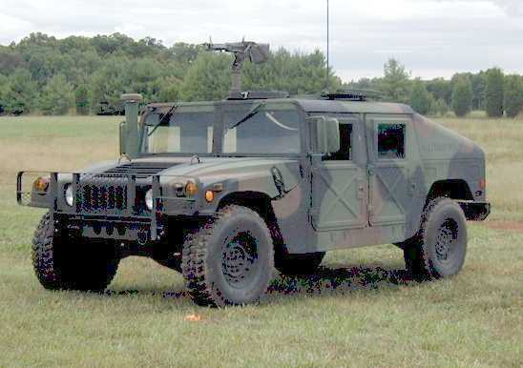
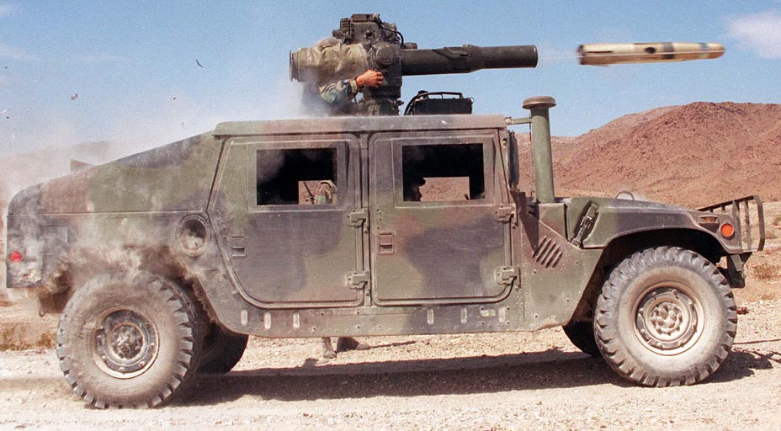
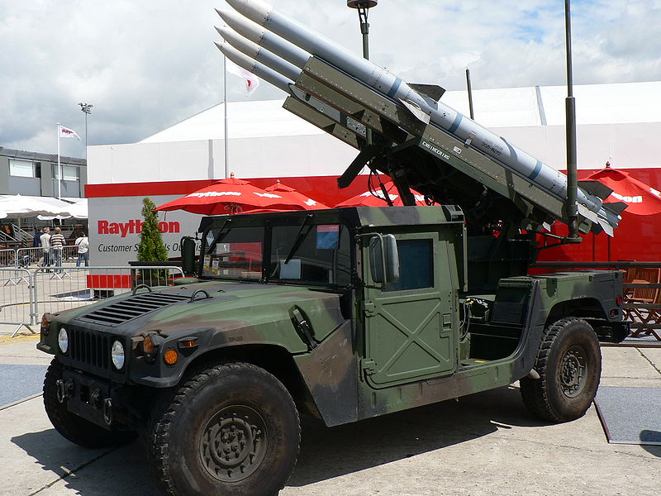
Browning
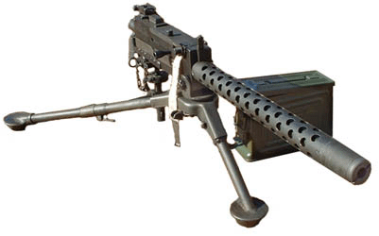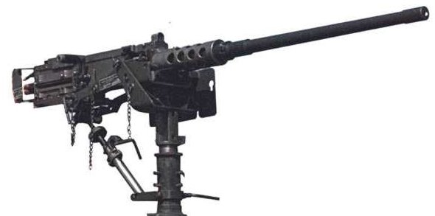

Vulcan
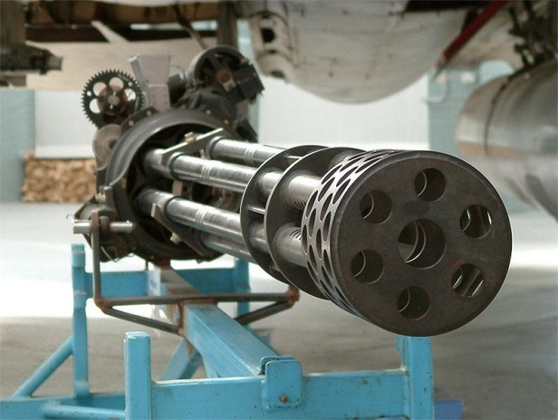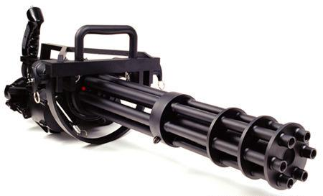

Rocket launcher
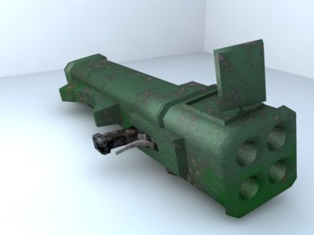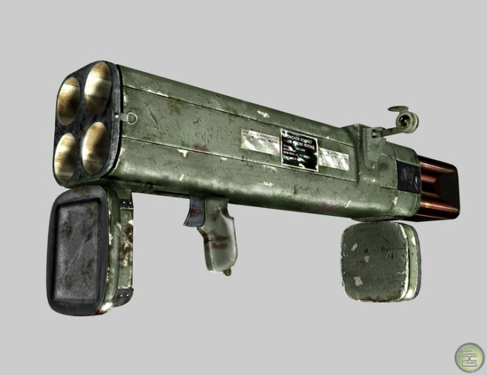

Mini rocket launcher
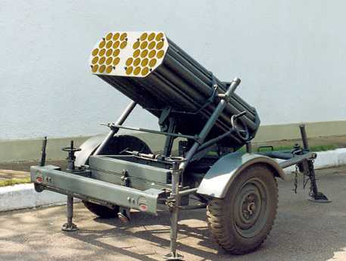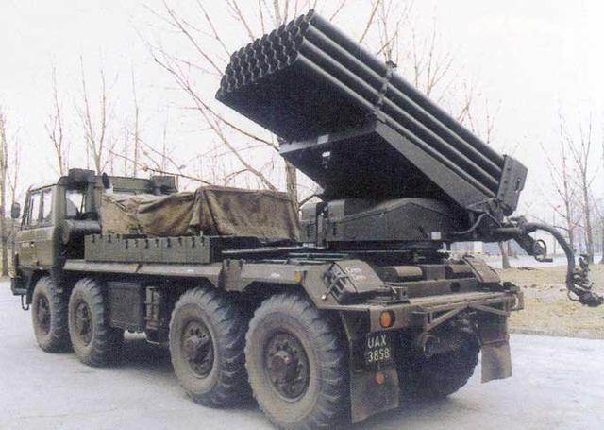

Grenade launcher
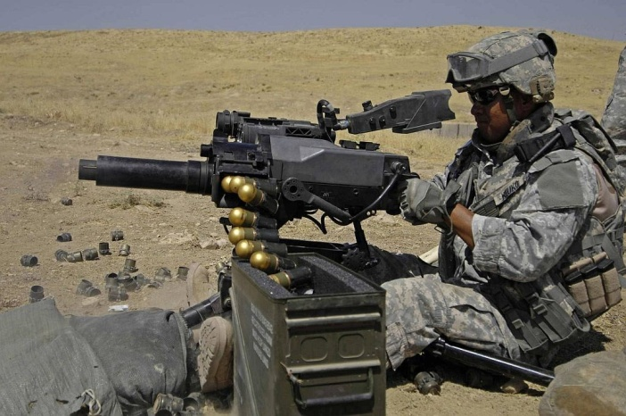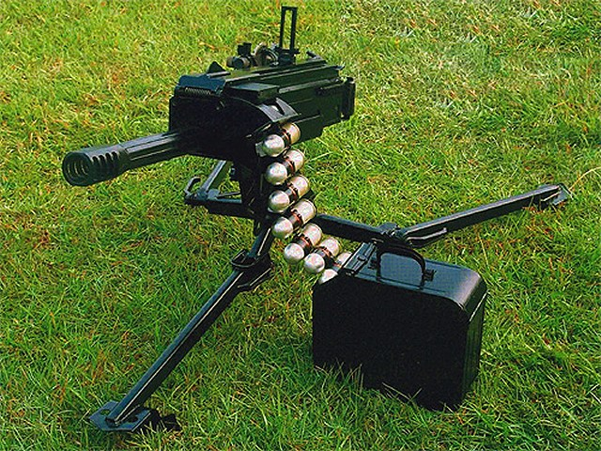

Chainsaw


SSM missiles
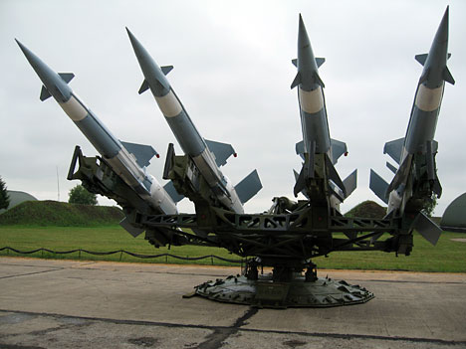

Tow missile
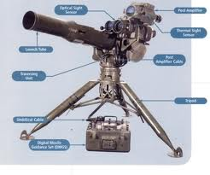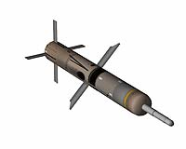

Burrow missile
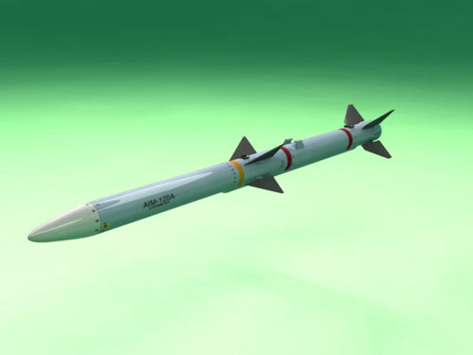

MG 42
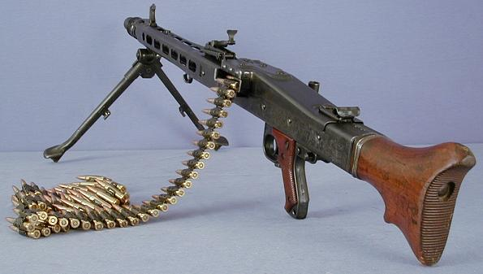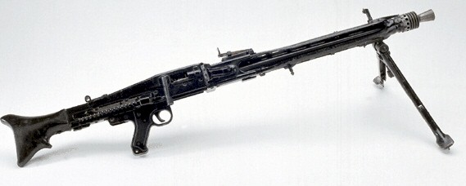

Oil
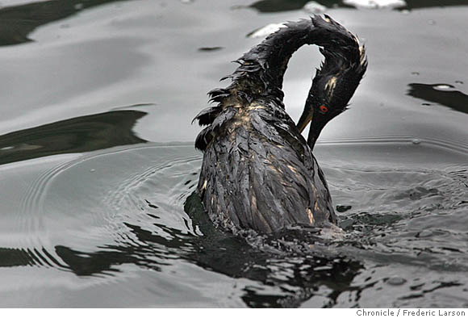

Caltrops
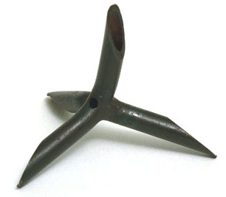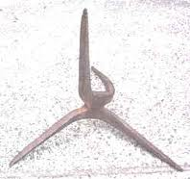

Smoke


Landmine
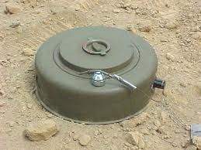

Gravity lift
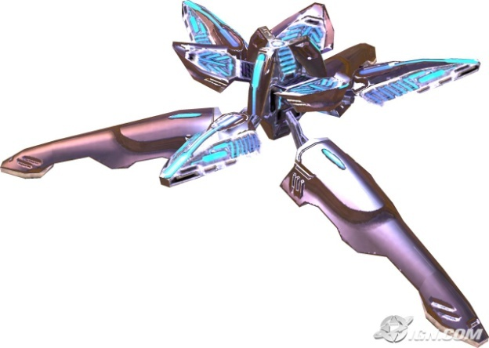

Teleporter


